**Sub001**

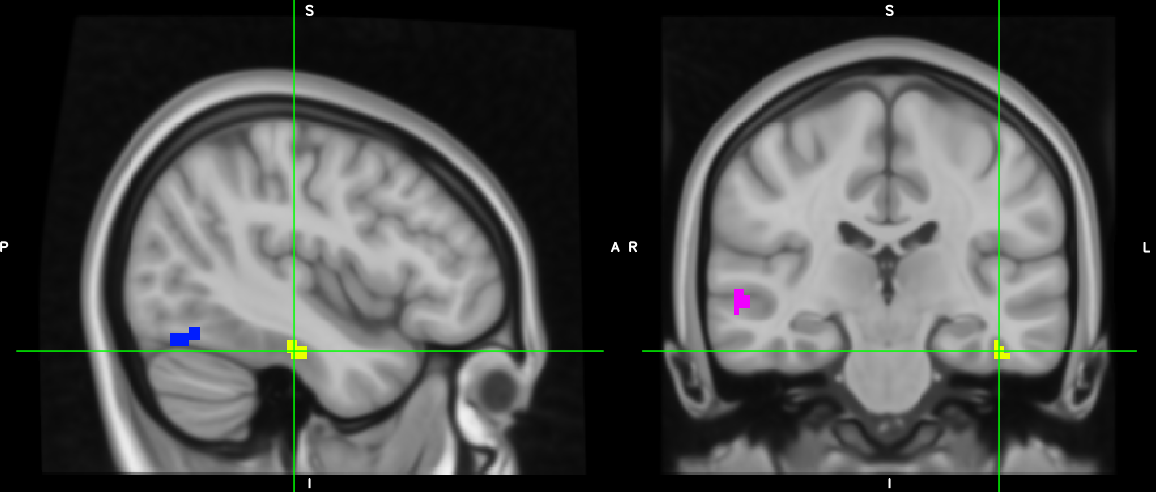

Should I use the yellow as FFA? (too anterior)

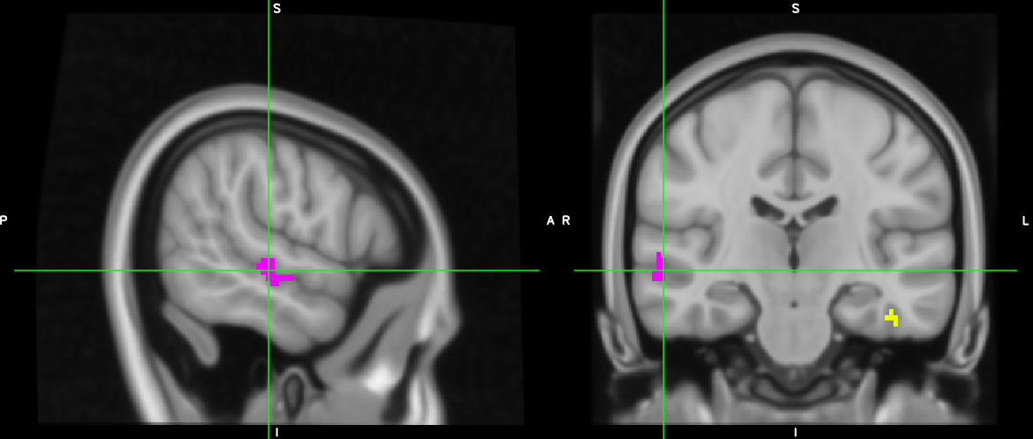

Should I include this STS? (too anterior)

**Sub 003**

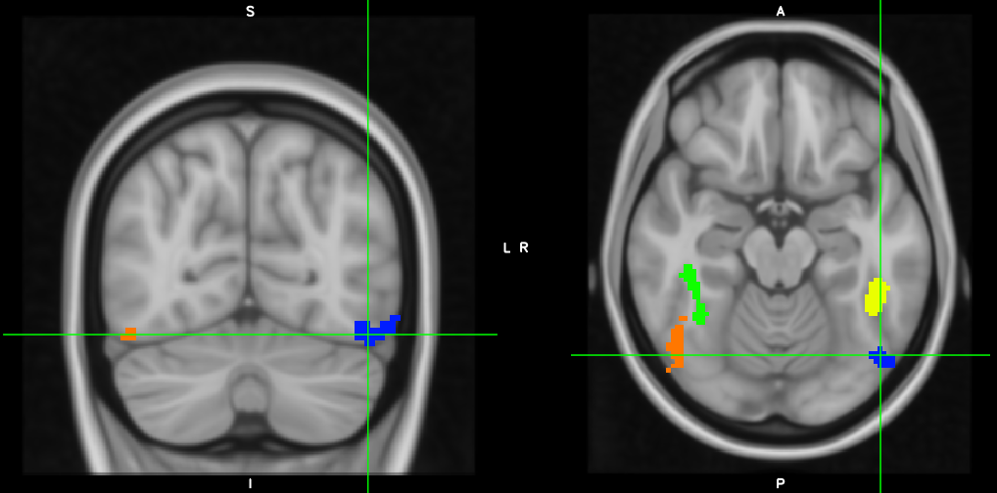

Are these OK OFA’s? (too lateral)

**Sub 004**

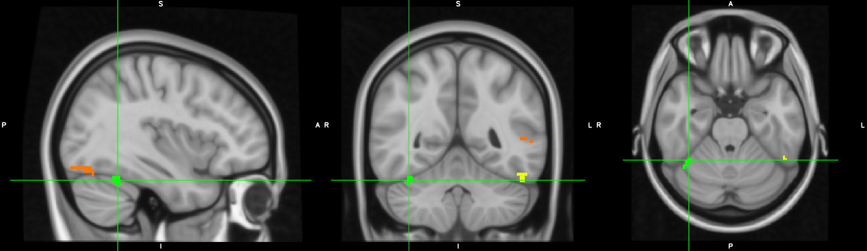

Use poorly registered green FFA cluster?

**Sub 006**

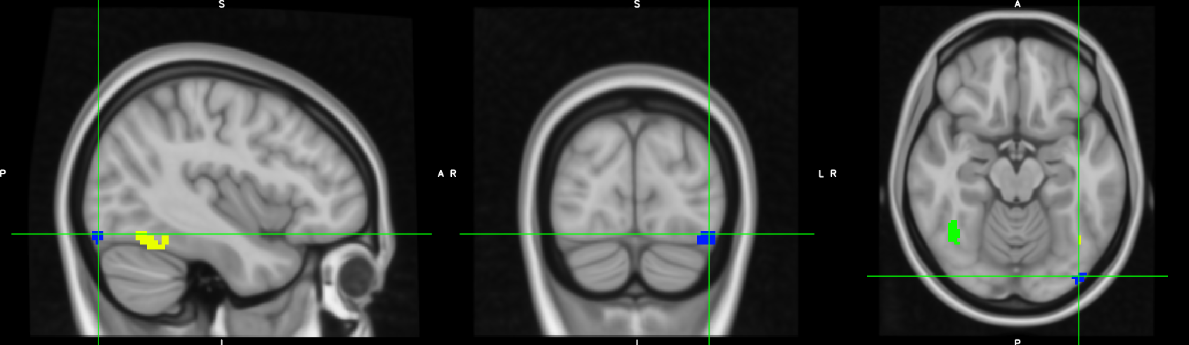

Blue OFA too lateral-posterior?

**Sub 010**

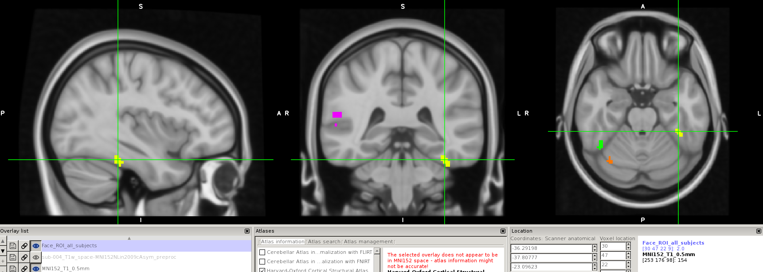

Yellow FFA - too anterior?

**Sub 011**

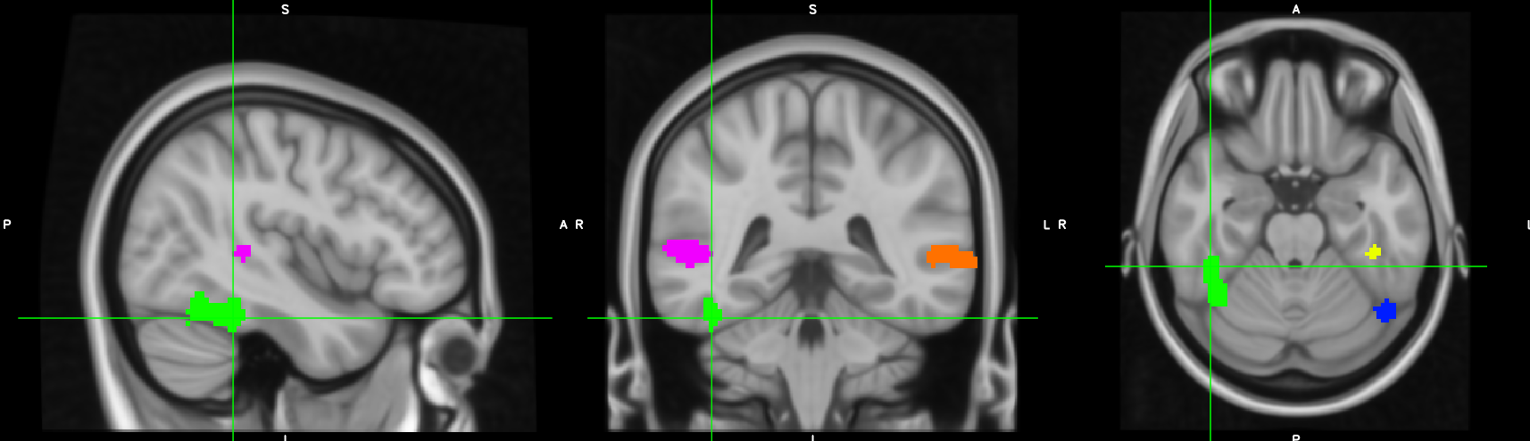

Yellow FFA too anterior?

Green FFA – looks OK? (not fused?)

**Sub 013**

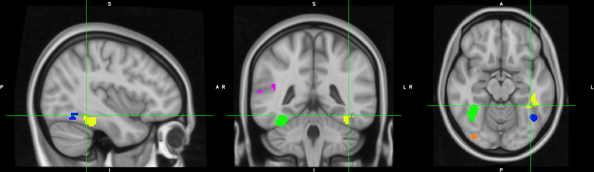

Not sure if left hemisphere is OK?

**Sub 020**

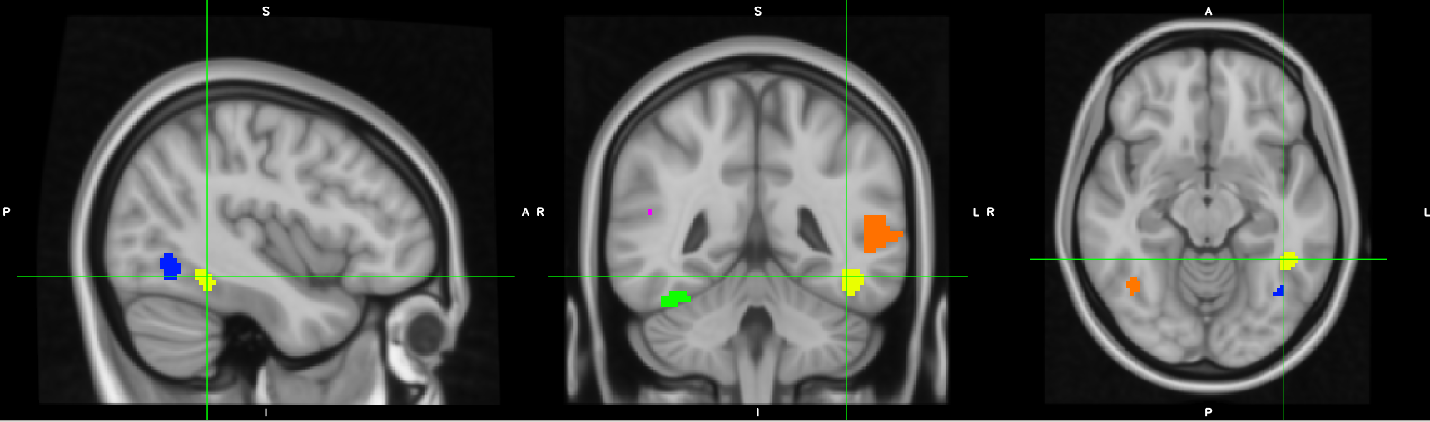

OK that FFA and OFA a bit high?

**Sub 022**

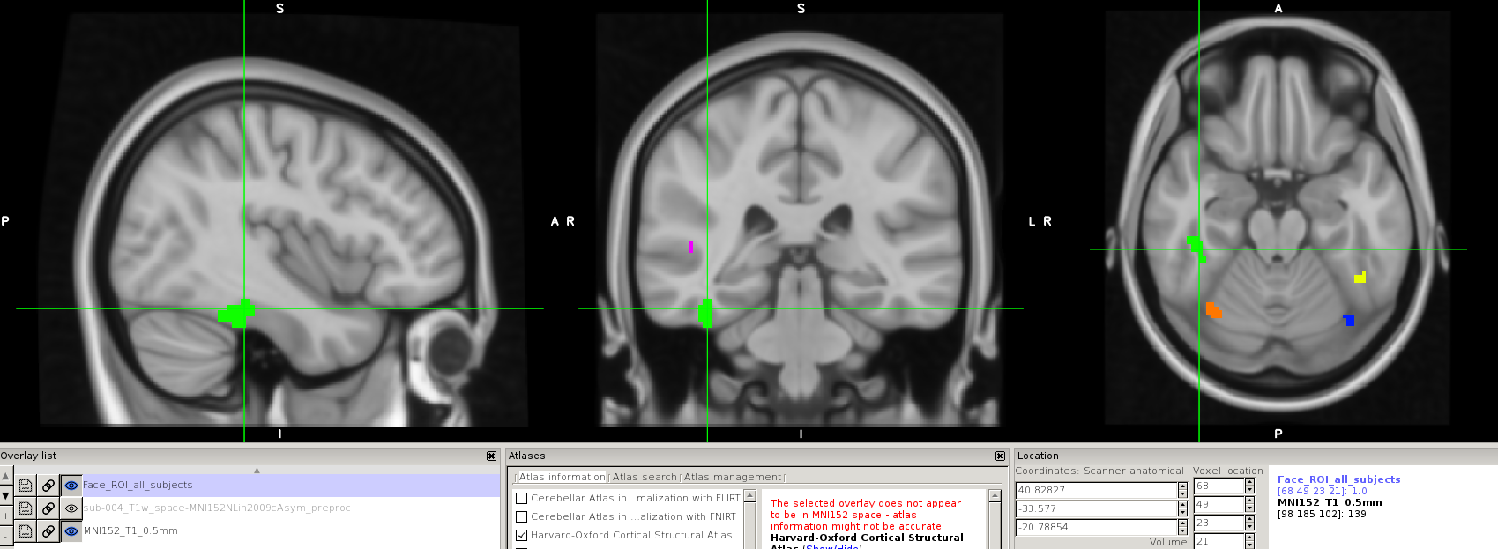

Green FFA too anterior?

**Sub 024**

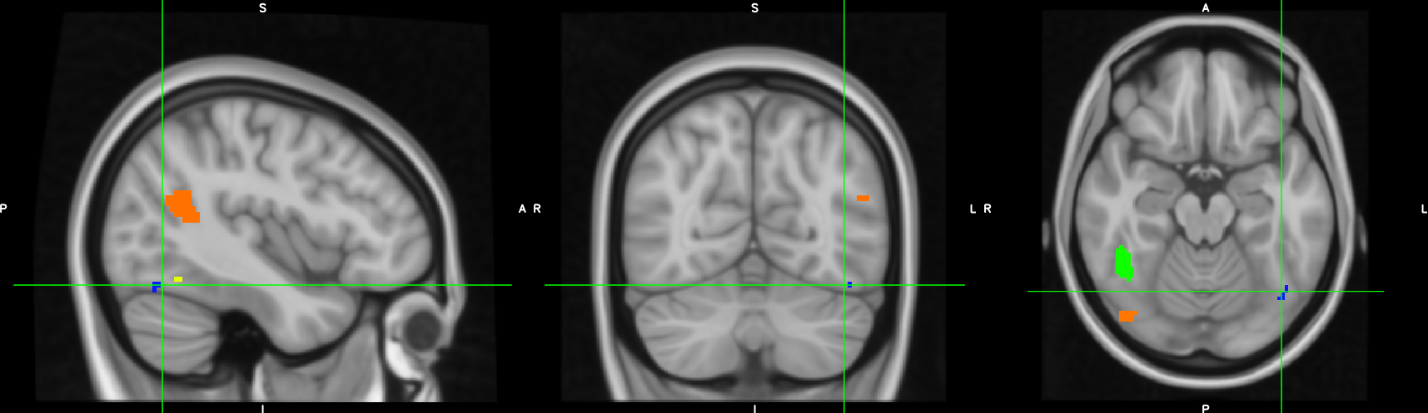

Use these tiny blue/yellow OFA and FFA?

**Sub 027**

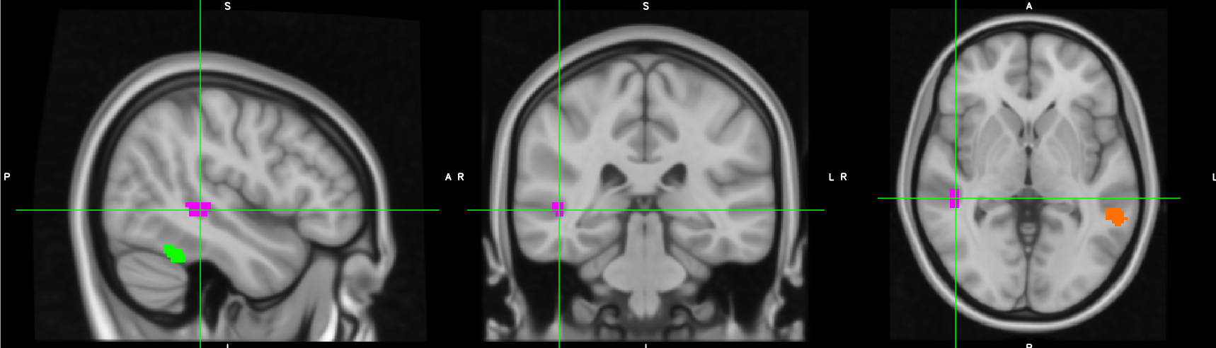

STS is OK (not too anterior?)

**Sub 031**

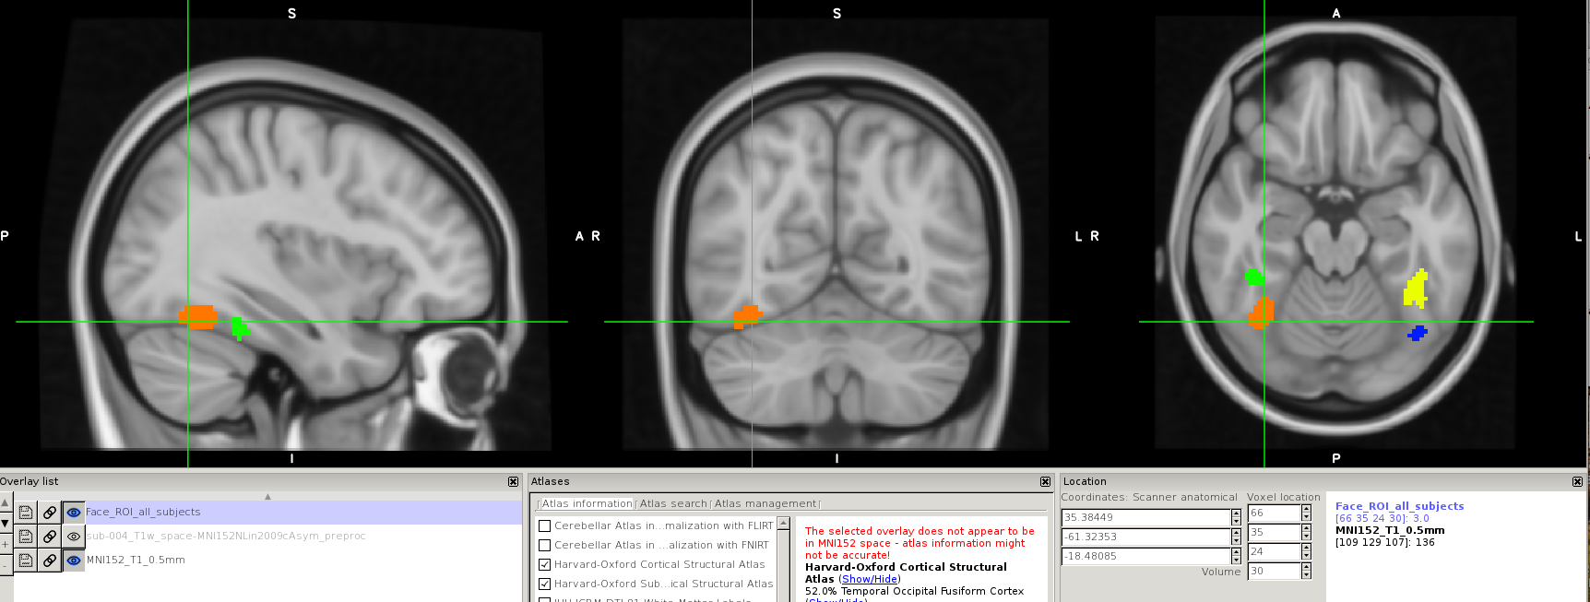

Is the orange OFA OK? (too anterior? Usually the area for FFA)

**Sub 035**

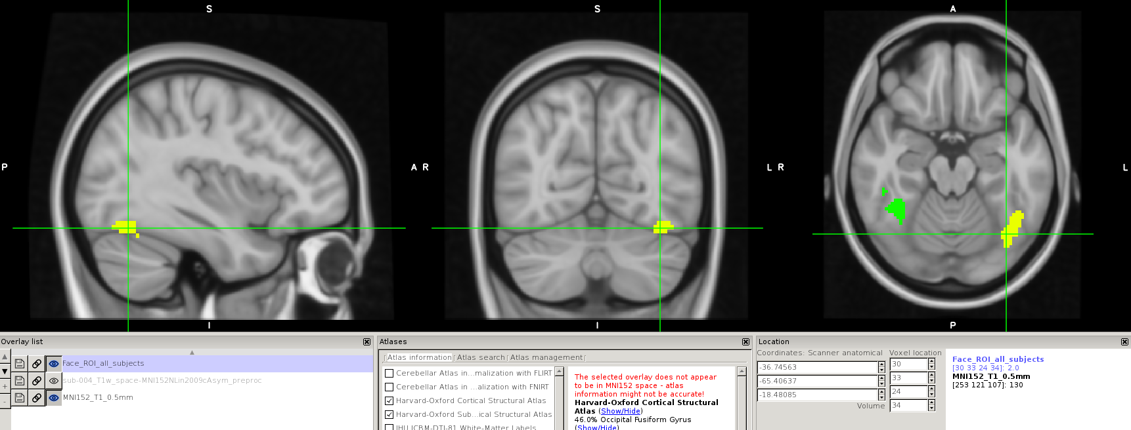

Yellow cluster is both FFA and OFA. Use it as FFA?

**Sub 040**

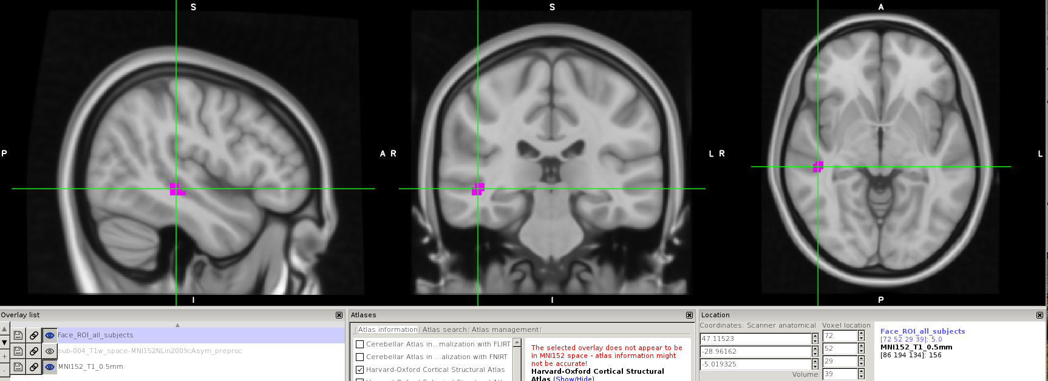

STS too anterior?

**Sub 045**

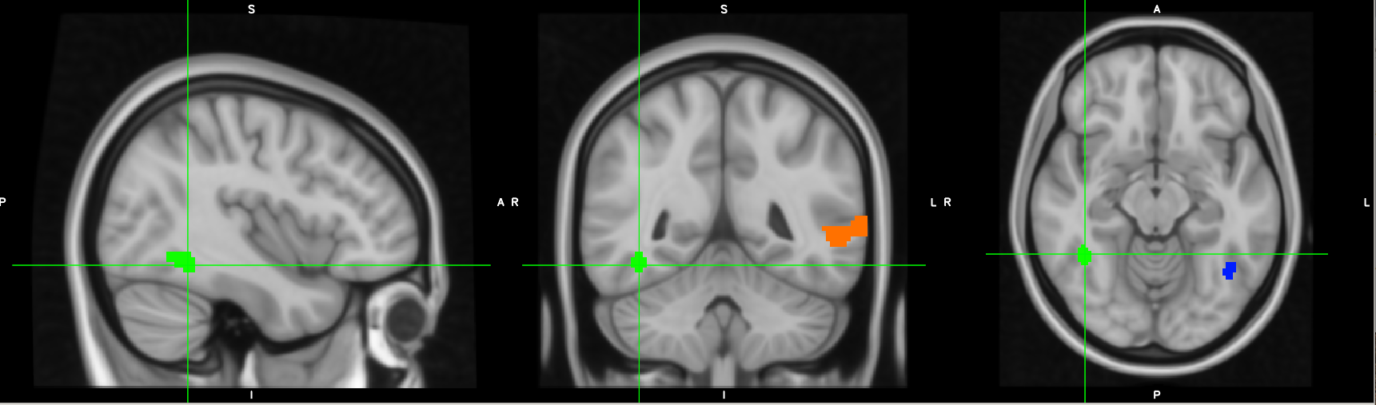

Use this high green FFA?

**Sub 049**

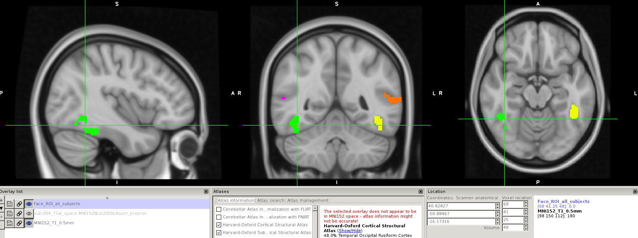

Green FFA is OK? Can’t split this cluster.